Impact of Interfacial Chemistry on electrochemical performance of composite magnetite electrodes
Miguel Gonzalez, Krysten Minnici, Bailey Risteen, Lei Wang, Lisa Housel, Genesis Renderos, Kenneth Takeuchi, Esther Takeuchi, Amy Marschilok, Thomas Fuller, and Elsa Reichmanis
Georgia Institute of Technology

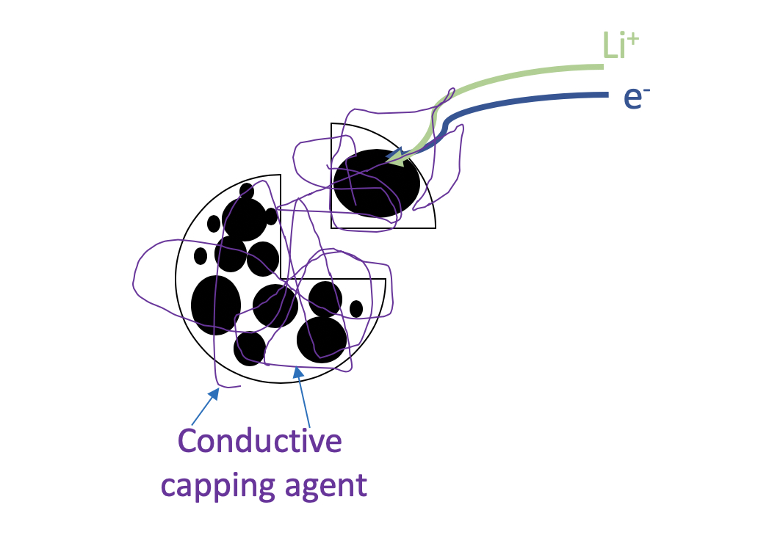
To meet the world’s increasingly diverse demand for energy storage, rational design of battery systems with specific performance characteristics are crucial in a wide-array of industries from automobiles to consumer electronics, among others. In this study, we used magnetite (Fe₃O₄) as a model active material to show how surface modification of the active material with different molecular entities of varying ionic/electronic conductivities changed the local surface chemical environment of the particles to greatly affect the electrochemical performance of the battery. We show that direct covalent attachment of poly [3-(4-carboxypropyl)thiophene] (PPBT) —a mixed ion conductor— creates a mat-like network stemming from the particle that creates anodes with enhanced lithium insertion kinetics and lithium transport processes integral in high discharge applications. These electrodes exhibit low charge transfer resistances, excellent charge capacity retention at 0.3 C, and robust charge capabilities/specific capacities. The simple attachment strategy relies on a Fischer Esterification scheme that attaches a carboxylic acid side chain of the polymer to the native hydroxide layer of the active material, thereby being applicable to the wide array of conversion-type electrodes that contain a hydroxide layer. This work contributes to the growing toolset of chemical techniques to modify active materials to create battery systems with specific performance characteristics and explores how the chemical properties of different small molecules and polymers affect the efficiency of capping agents.

