Title: Approaches to stereocontrol in metal free ring-opening metathesis polymerization

Ring-opening metathesis polymerization (ROMP) is one of the most widely used strategies for controlled polymerizations. Although metal alkylidene initiators enable the synthesis of functional polymers with excellent stereocontrol, residual metal contamination and high costs of metal reagents are major limitations of ROMP. In a departure from traditional metal initiators, our group recently reported a metal free variant of ROMP (MF-ROMP) which utilizes enol ether initiators, and organic photocatalysts to achieve ROMP via radical cationic intermediates. Within the unique mechanism of MF-ROMP, we have discovered that ion-pairing interactions provide a means to impart stereocontrol during polymerization. During this talk, we will describe our initial discovery of stereocontrol in MF-ROMP and discuss our mechanistic hypotheses. Key parameters include examination of enol ether influences, pyrylium counteranion structure reactivity relationships, and solvent effects. We will conclude with a discussion about the materials properties of stereocontrolled MF-ROMP products.

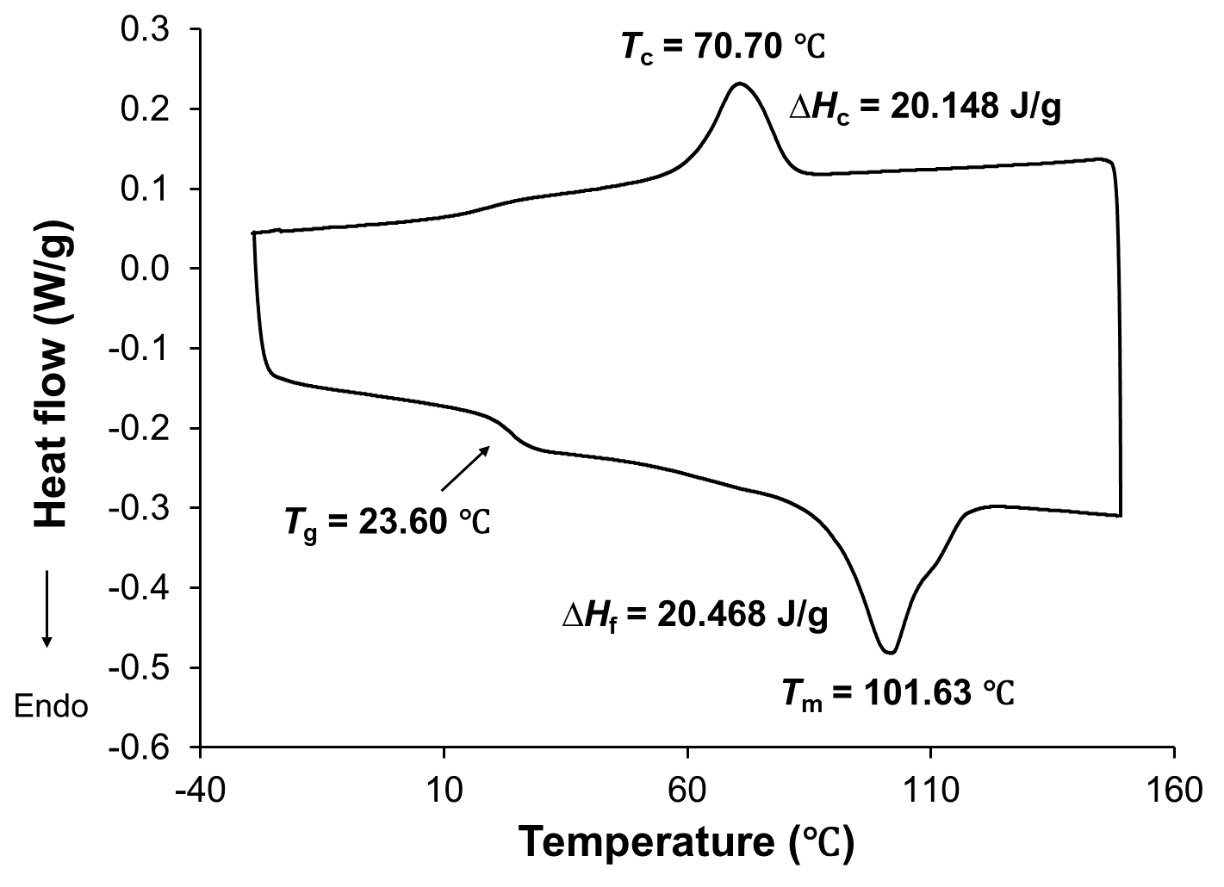

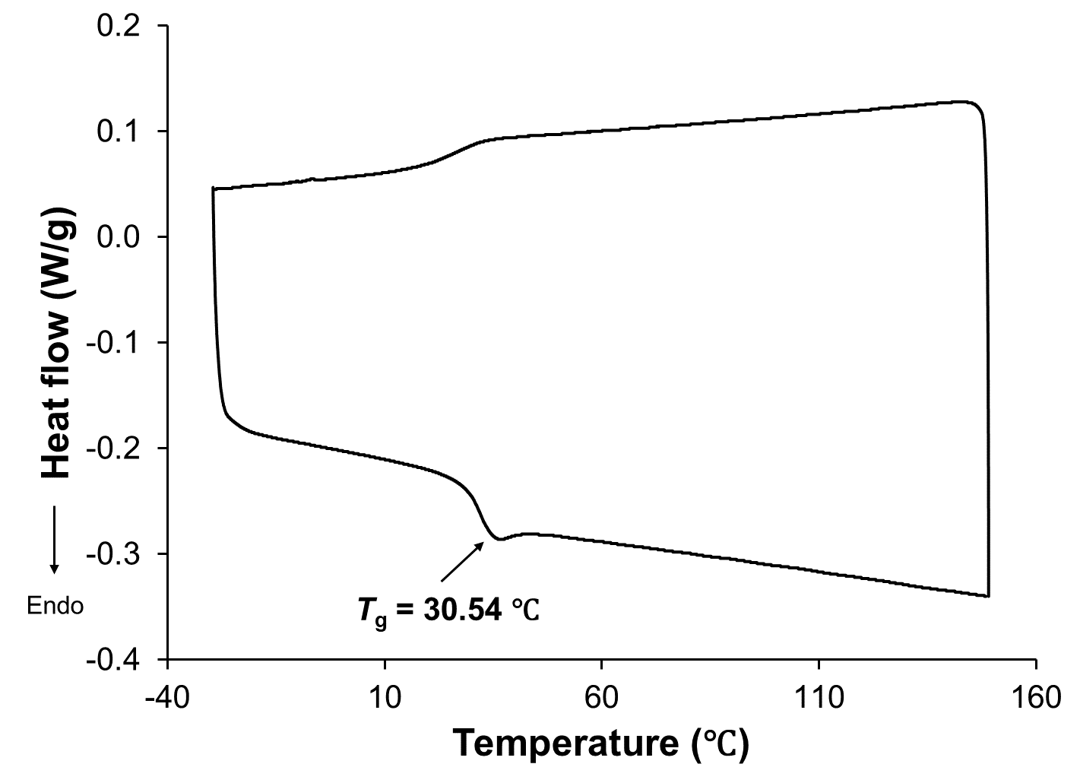
tunable stereochemistry tunable materials properties

